Nomadic Home Page 1/2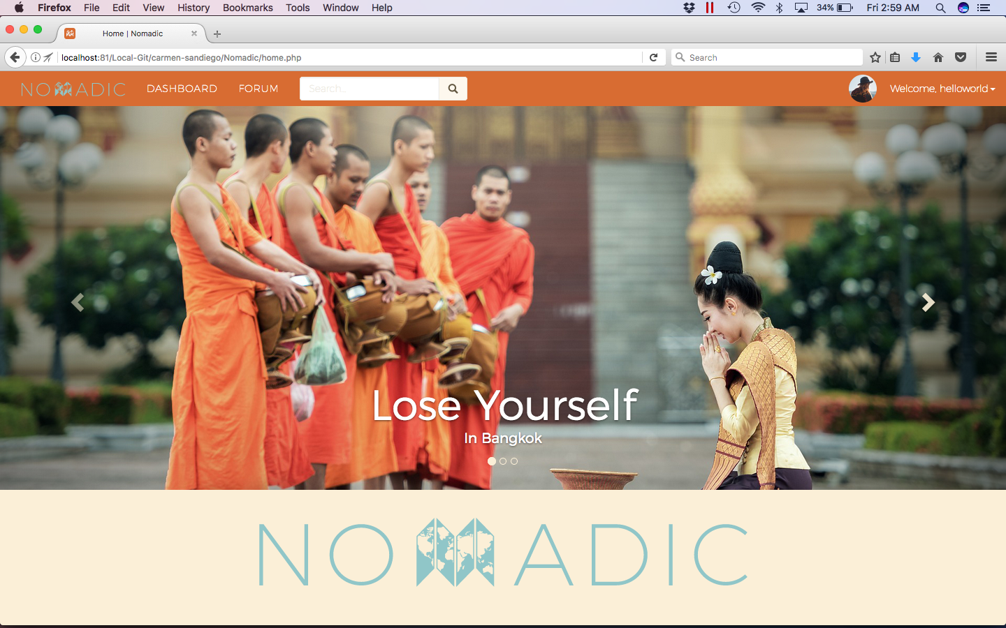

Nomadic Home Page 2/2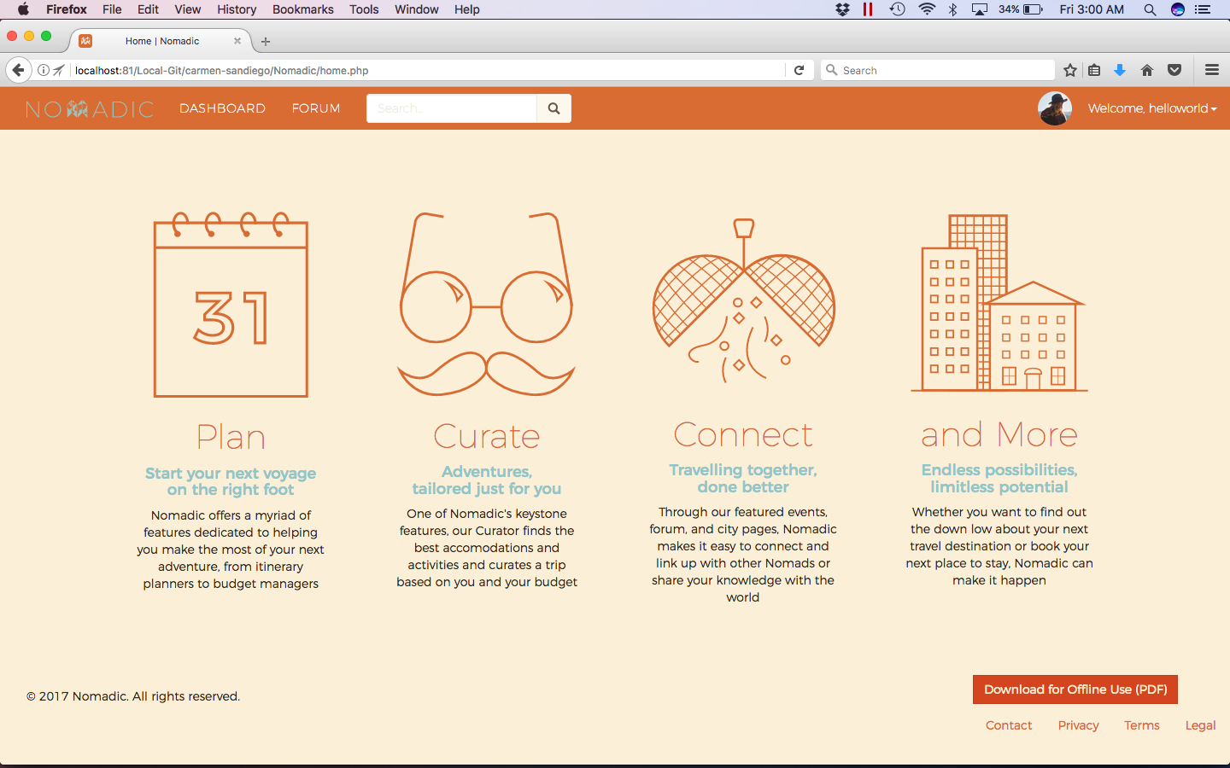

Nomadic Forum 1/3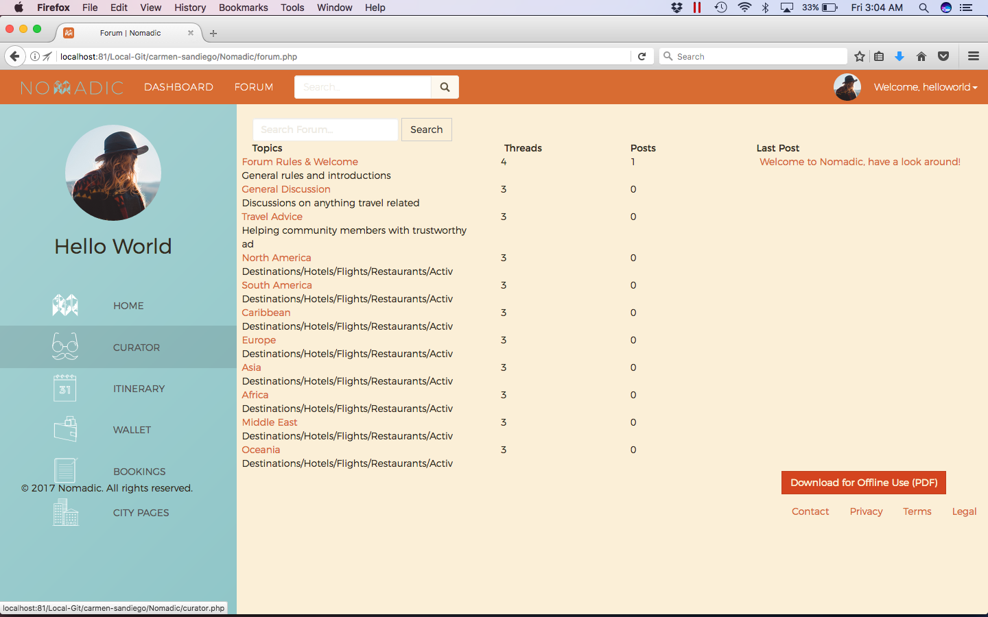

Nomadic Forum 2/3 (Topic List)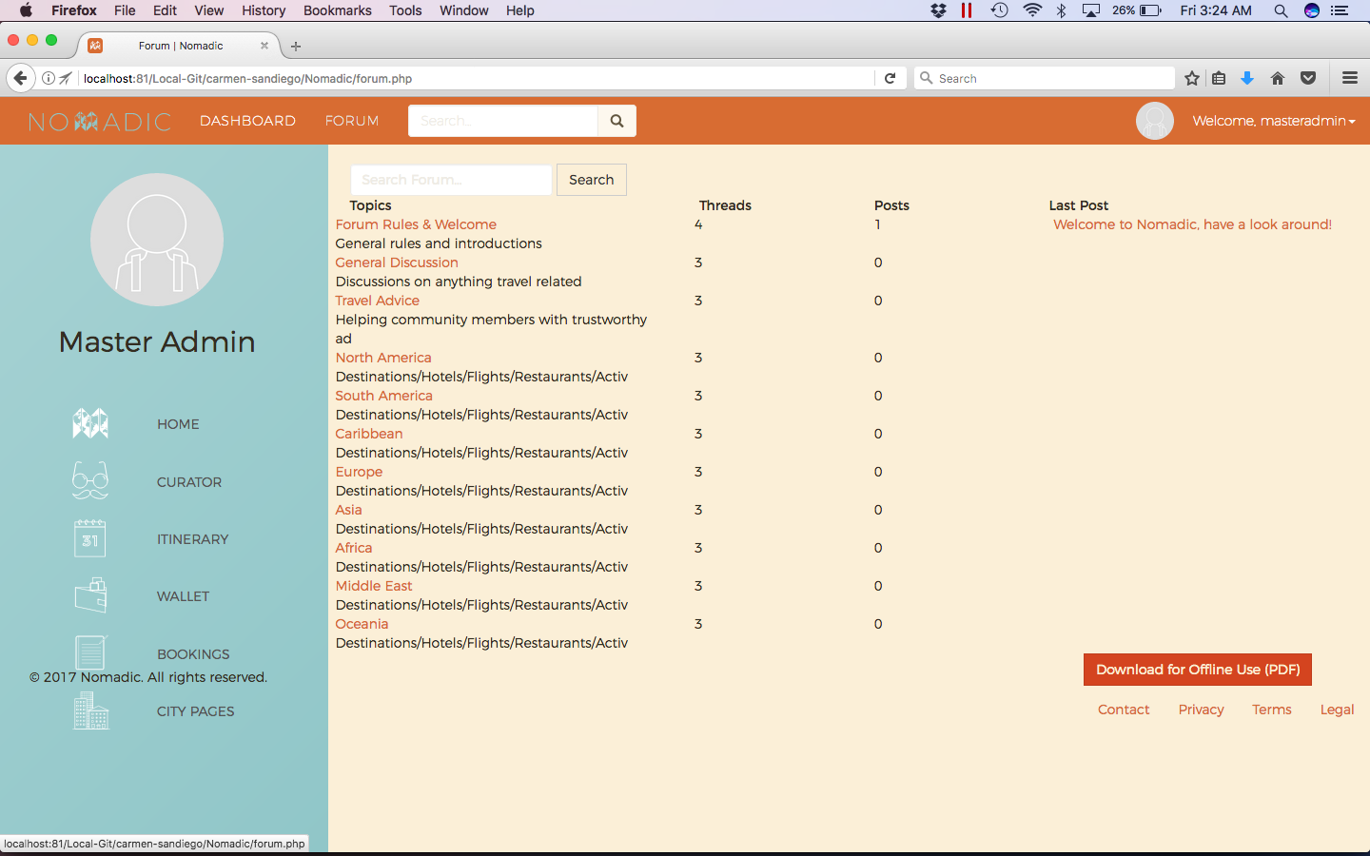

Nomadic Forum 2/3 (Thread)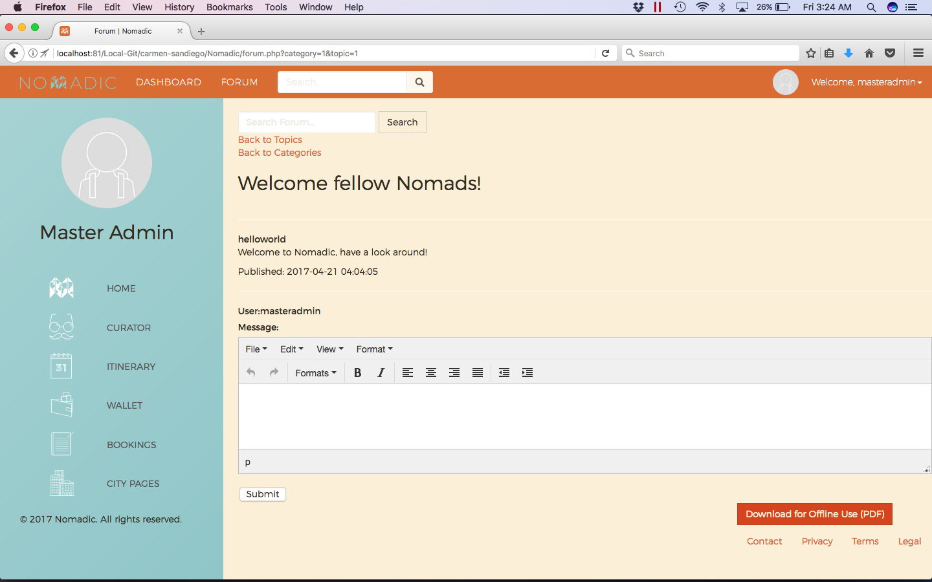

Nomadic Curator 1/3 (Form)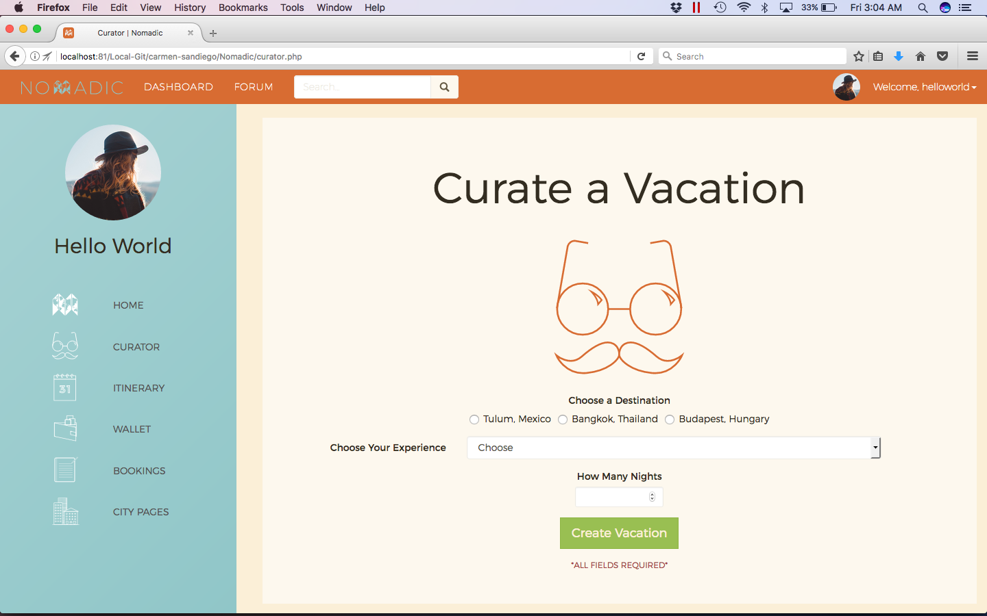

Nomadic Curator 2/3 (Result)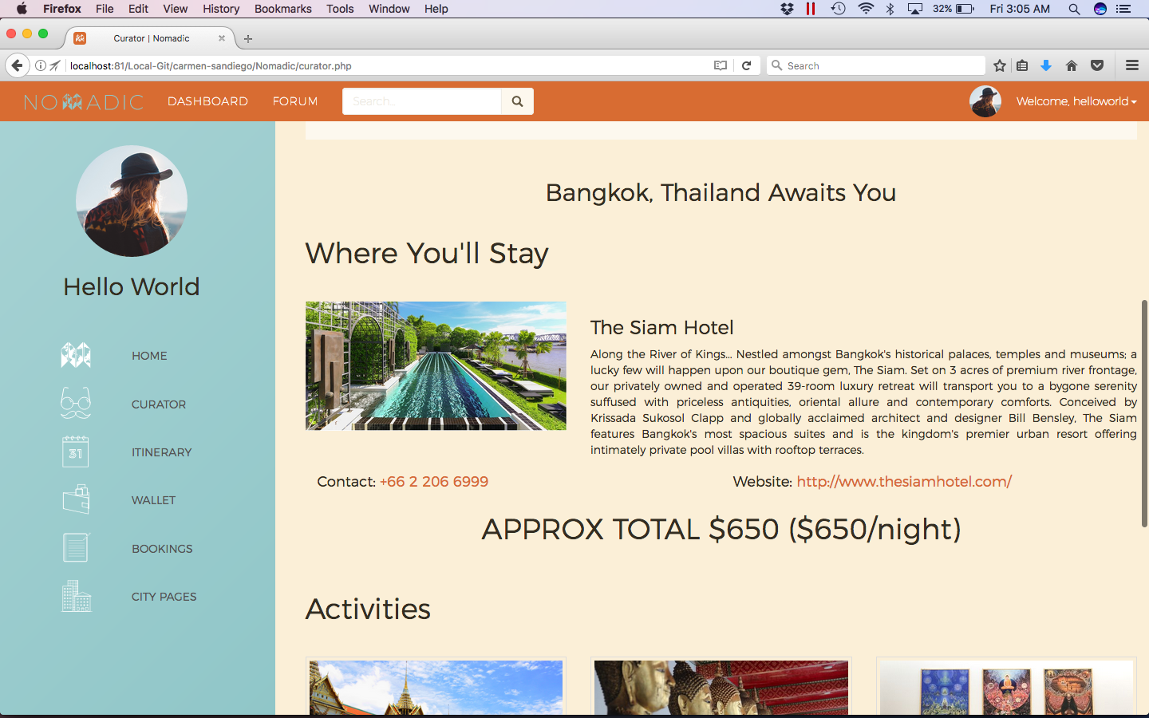

Nomadic Curator 3/3 (Result Continued)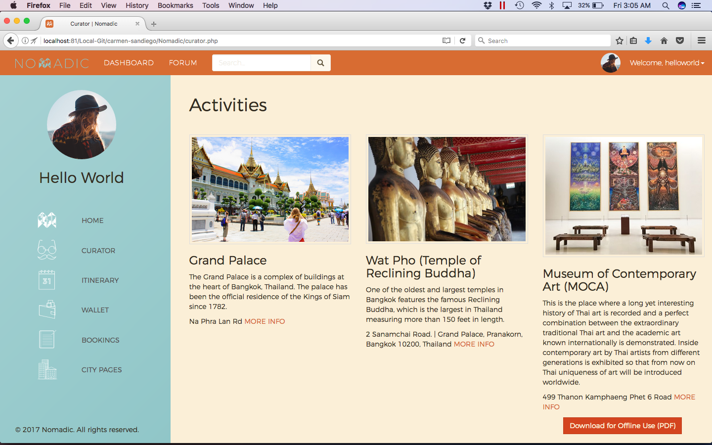

Nomadic Itinerary Planner 1/4 (Create Vacation)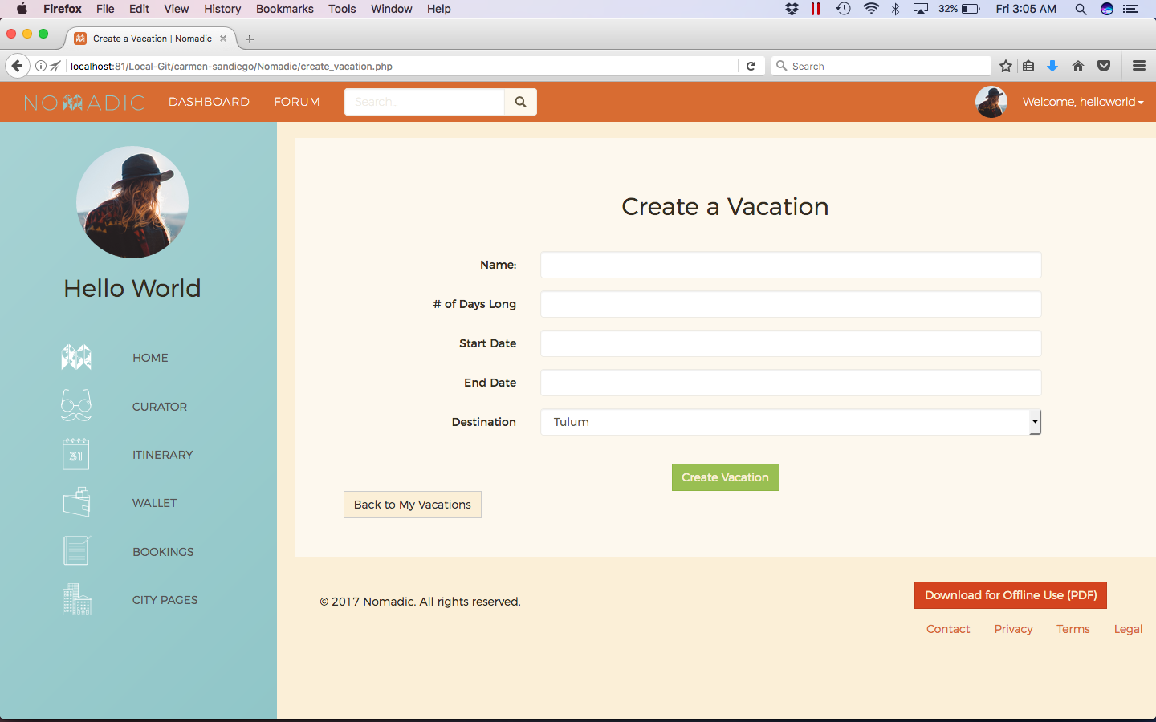

Nomadic Itinerary Planner 2/4 (View Vacations)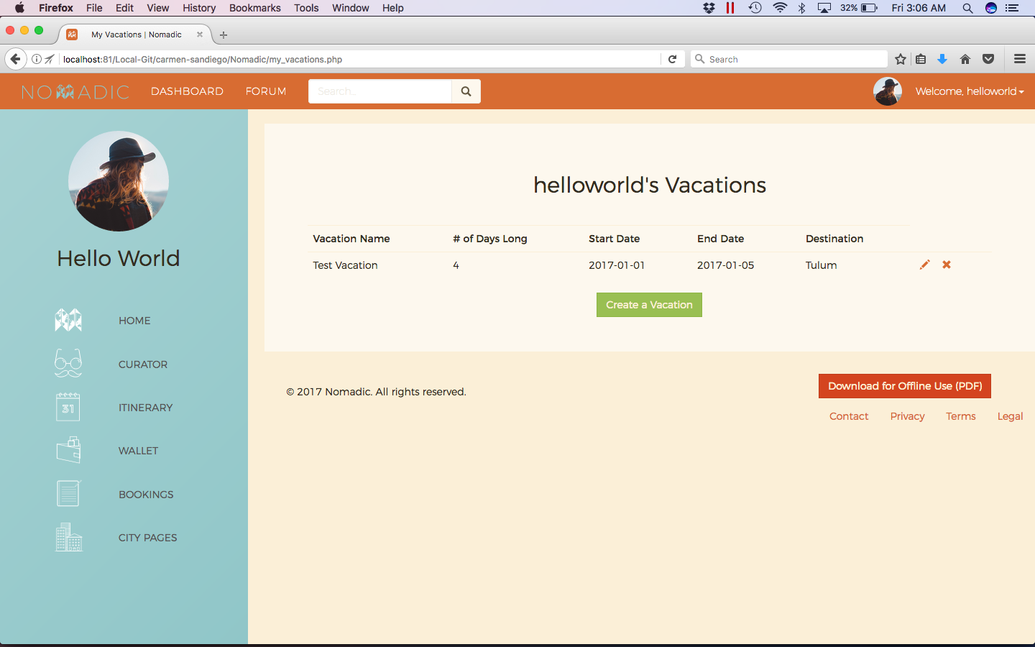

Nomadic Itinerary Planner 3/4 (Edit/Details of Vacation)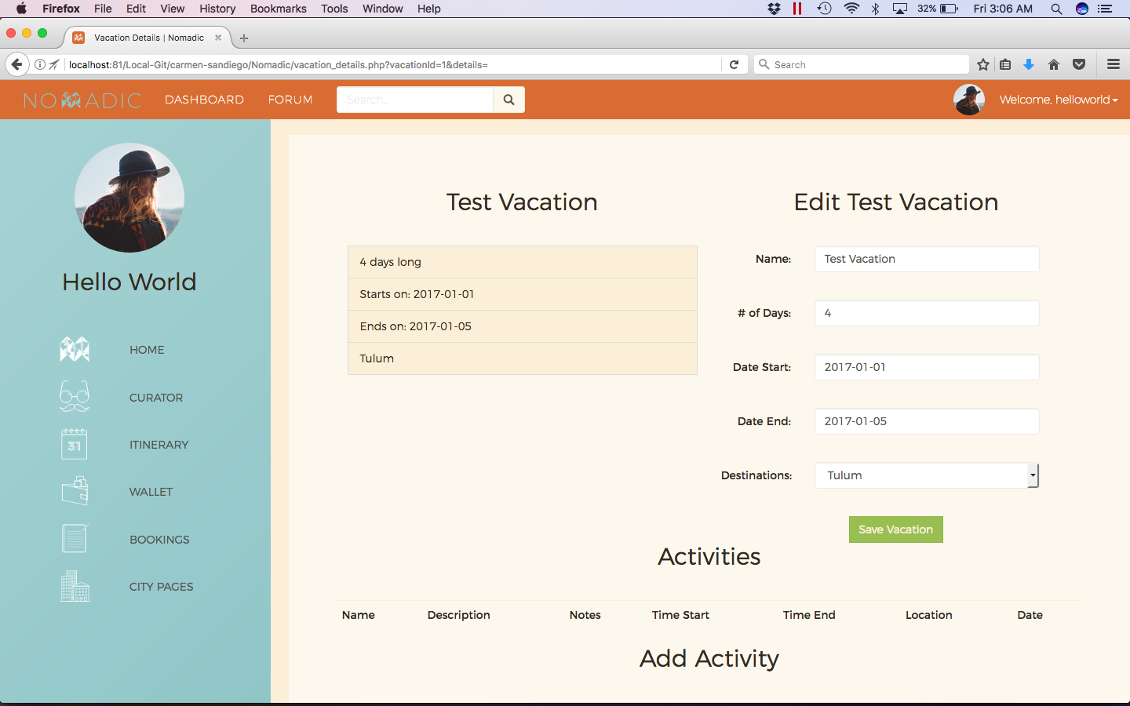

Nomadic Itinerary Planner 4/4 (Add Activity)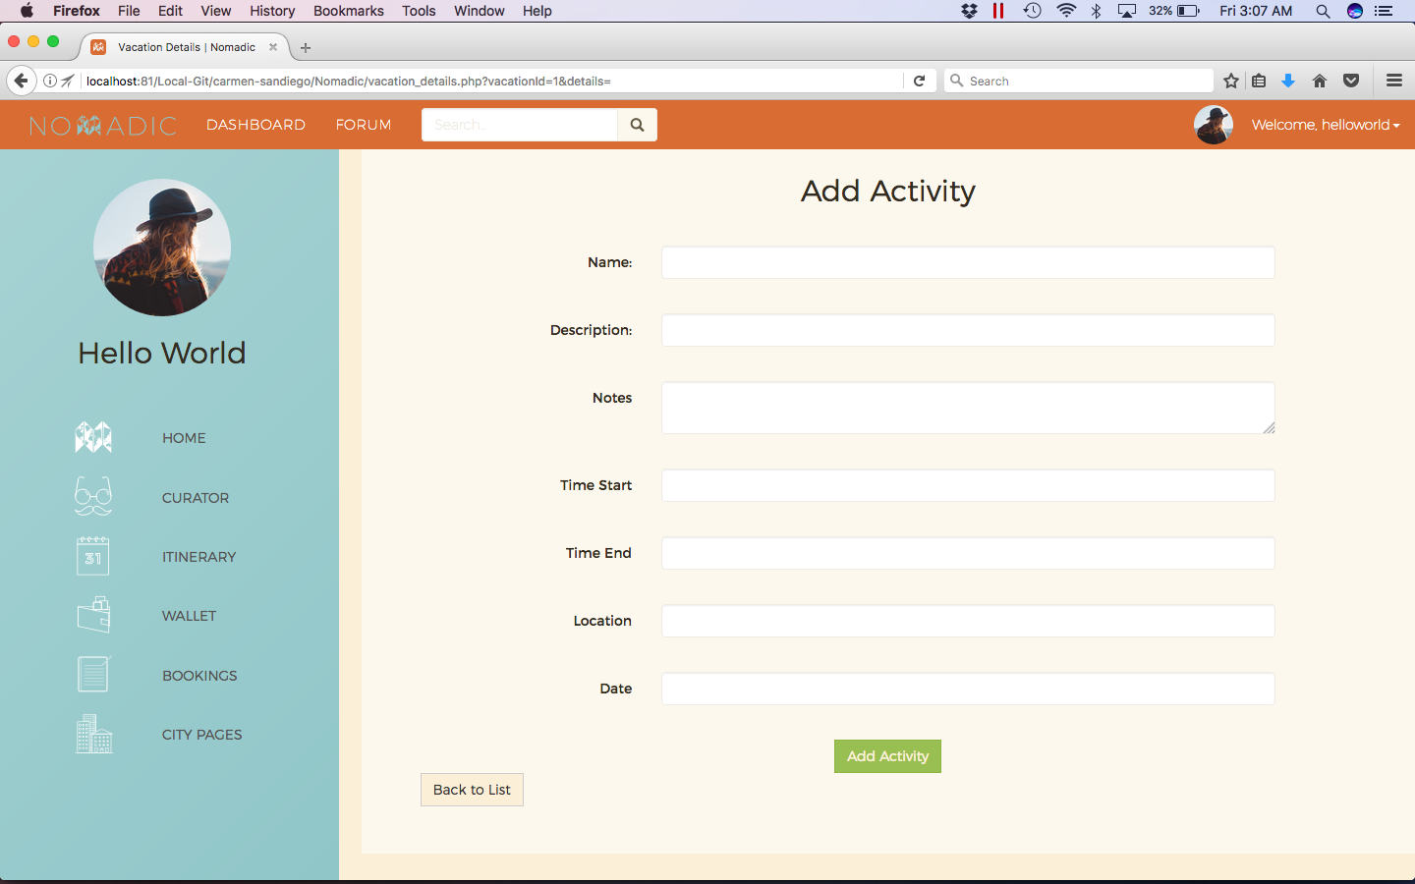

Nomadic Budget 1/3 (Create Budget)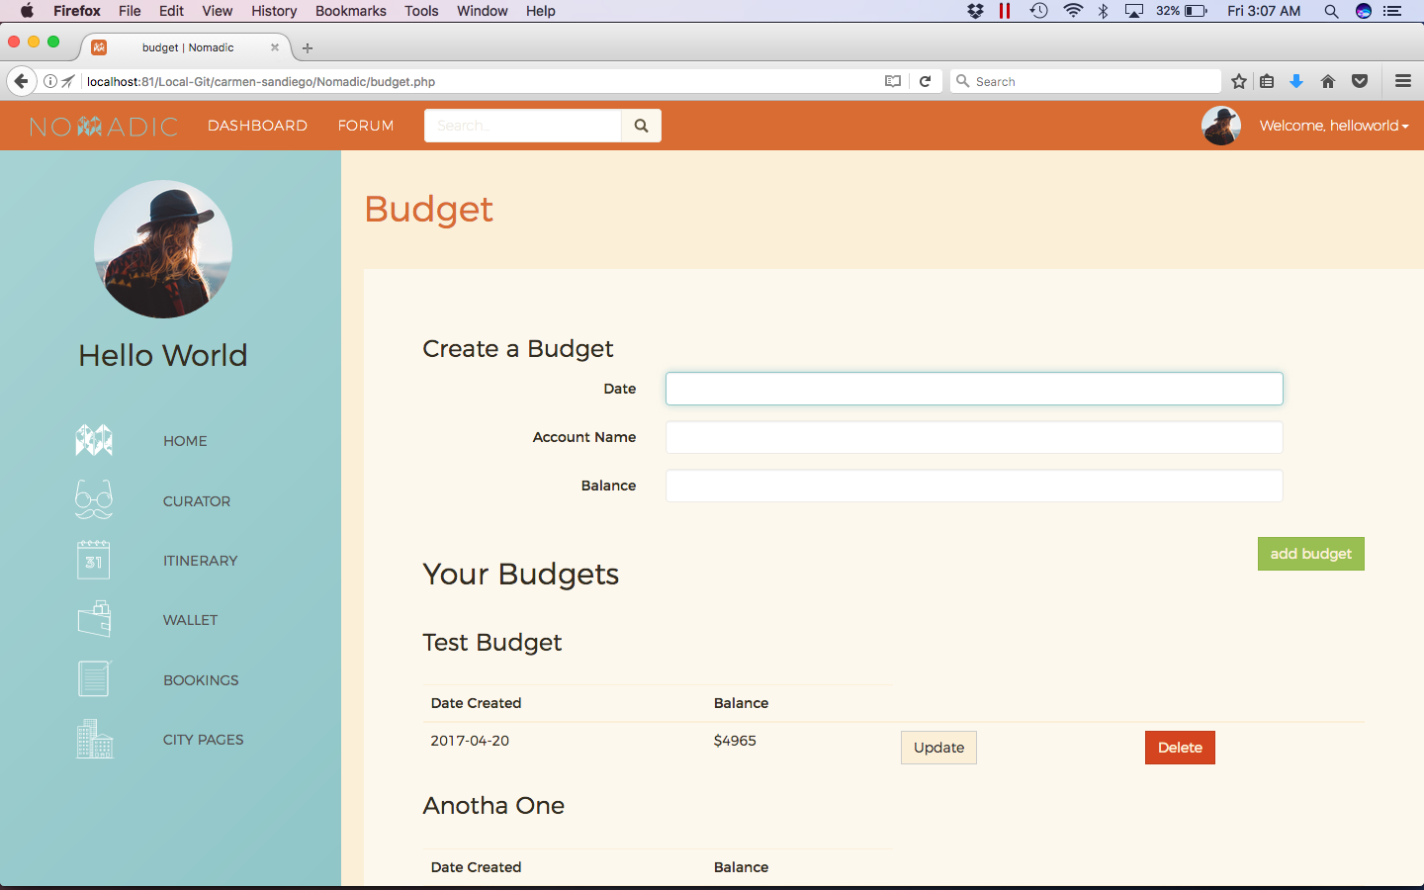

Nomadic Budget 2/3 (View Budgets)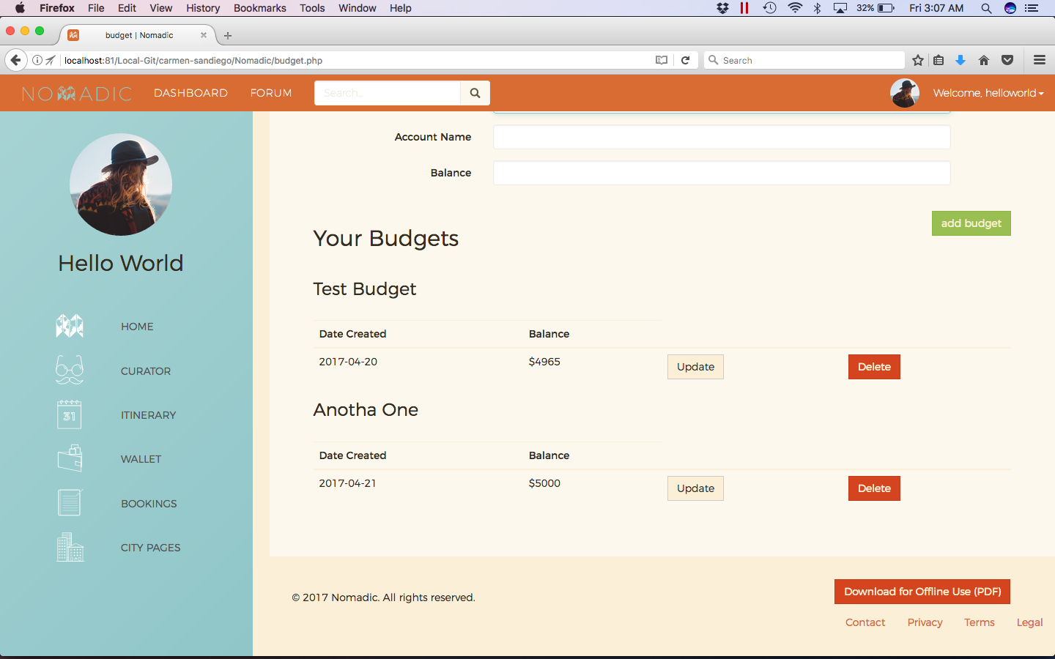

Nomadic Budget 3/3 (Edit/Details of Budget)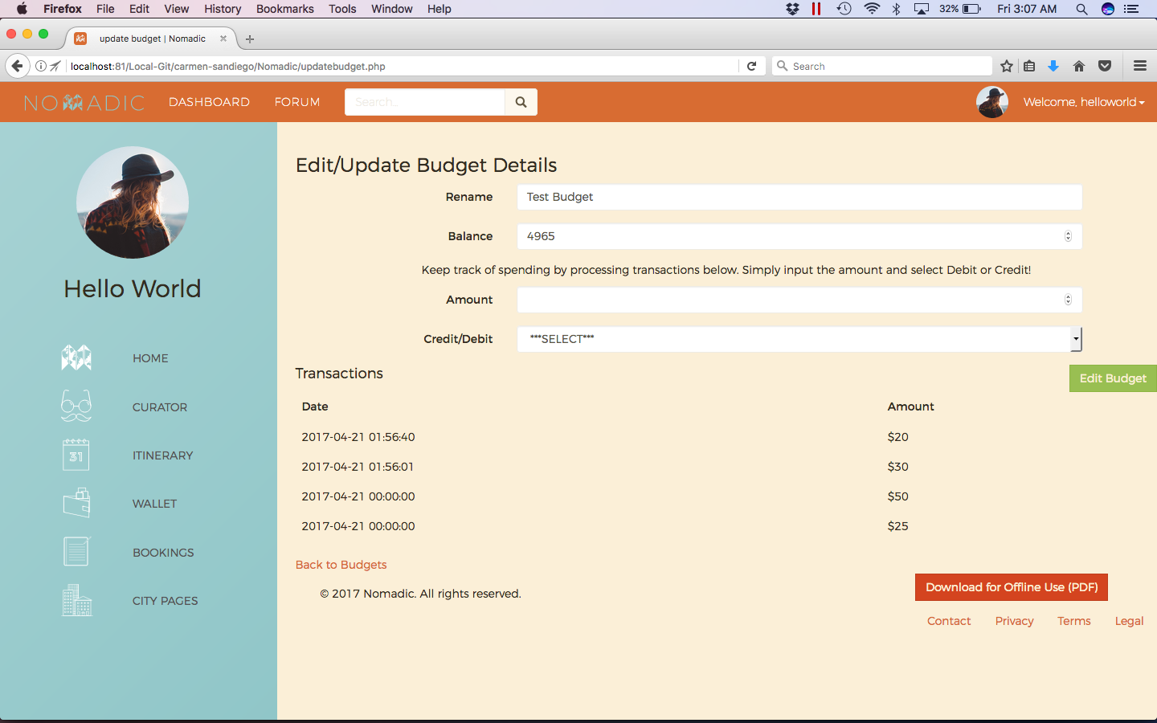

Nomadic Booking 1/2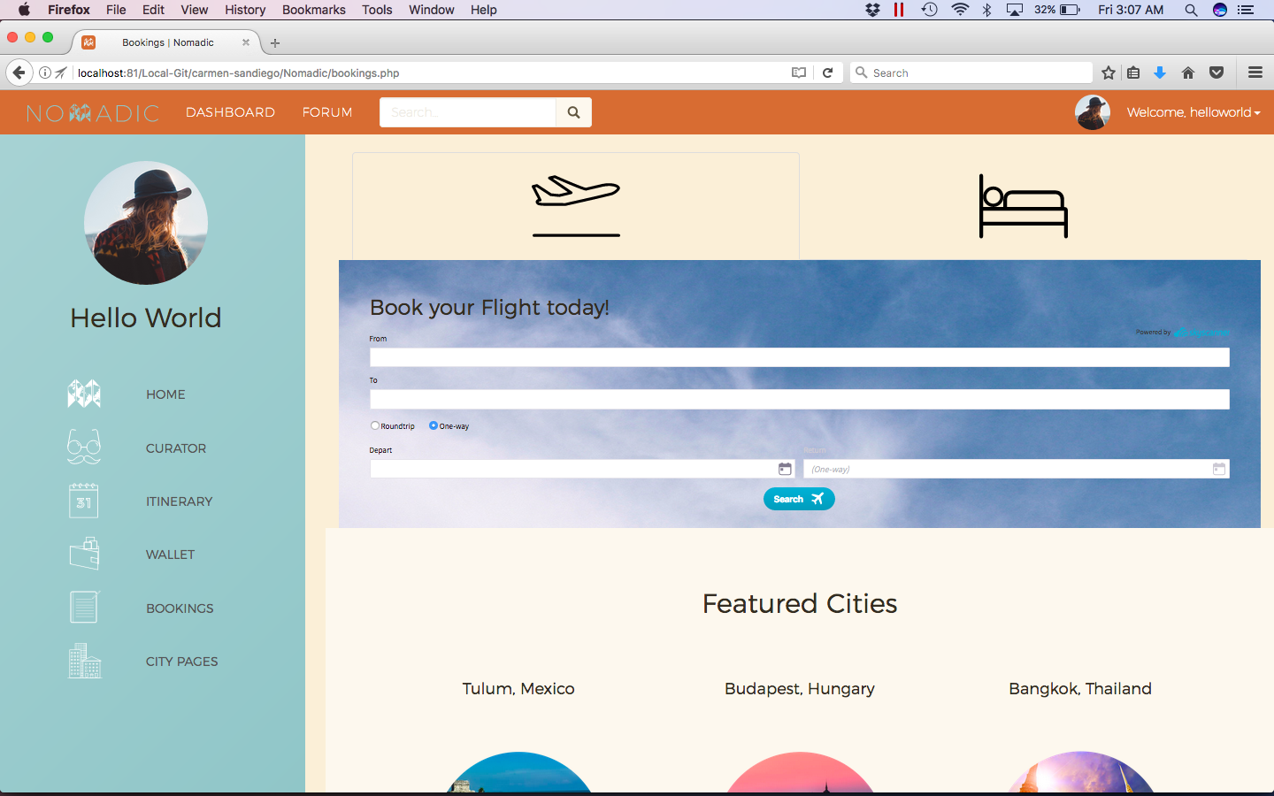

Nomadic Booking 2/2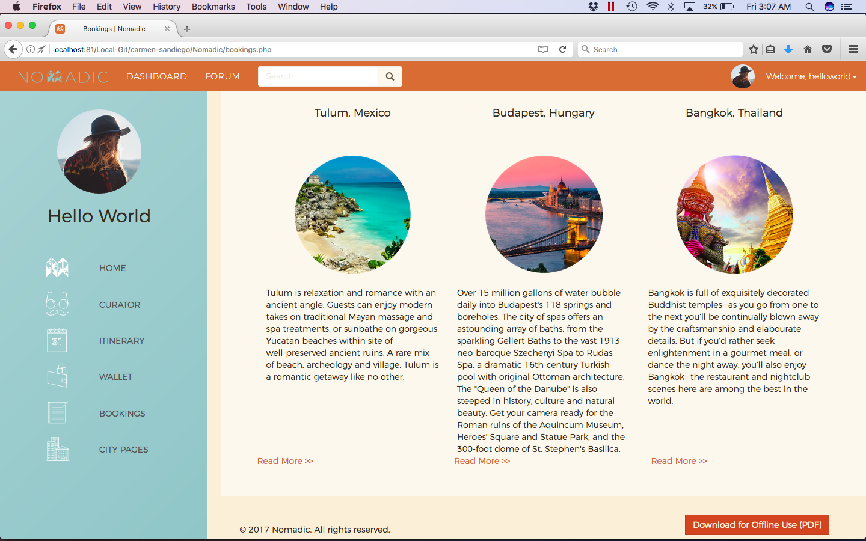

Nomadic City Pages 1/8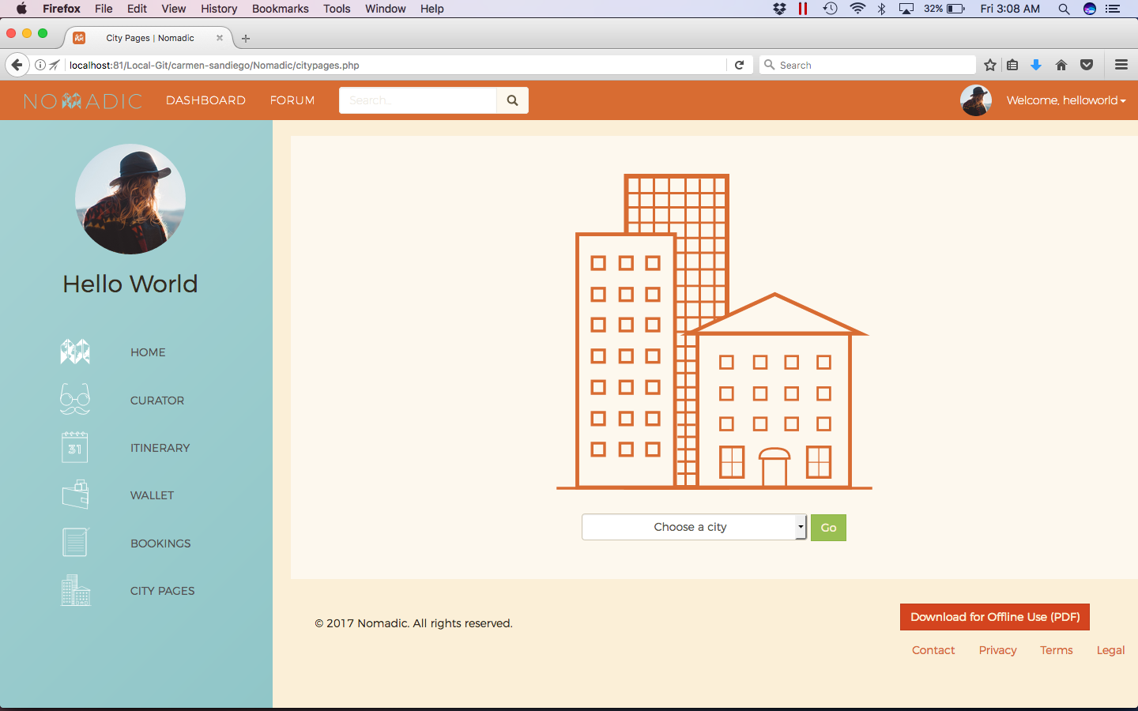

Nomadic City Pages 2/8 (City Selected)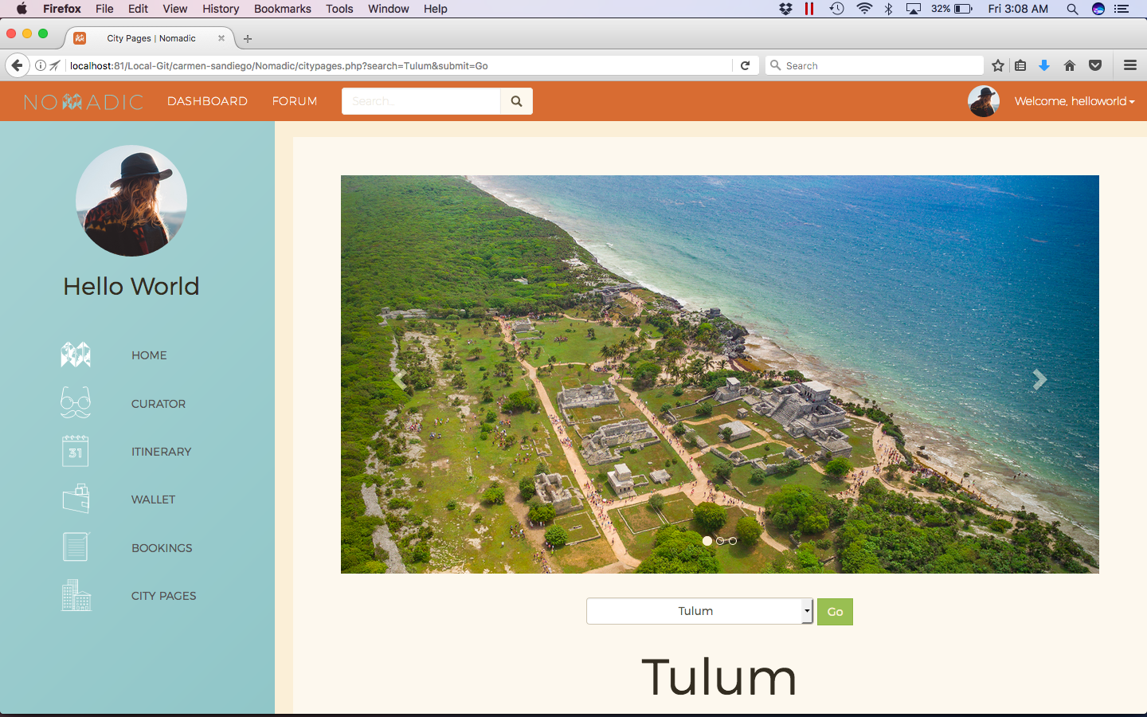

Nomadic City Pages 3/8 (City Selected Continued)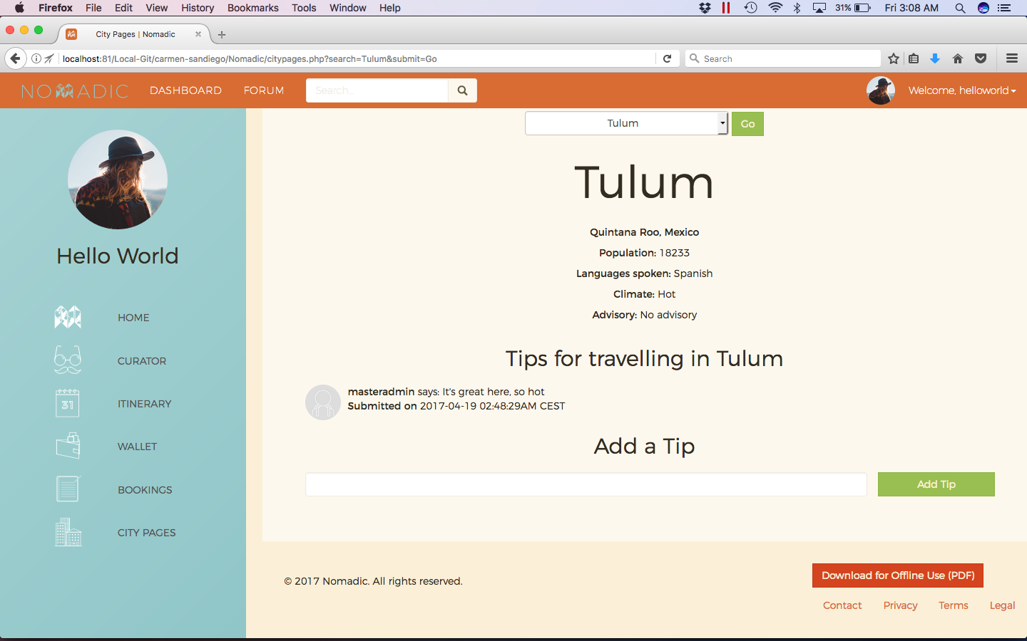

Nomadic City Pages 4/8 (Administrator View)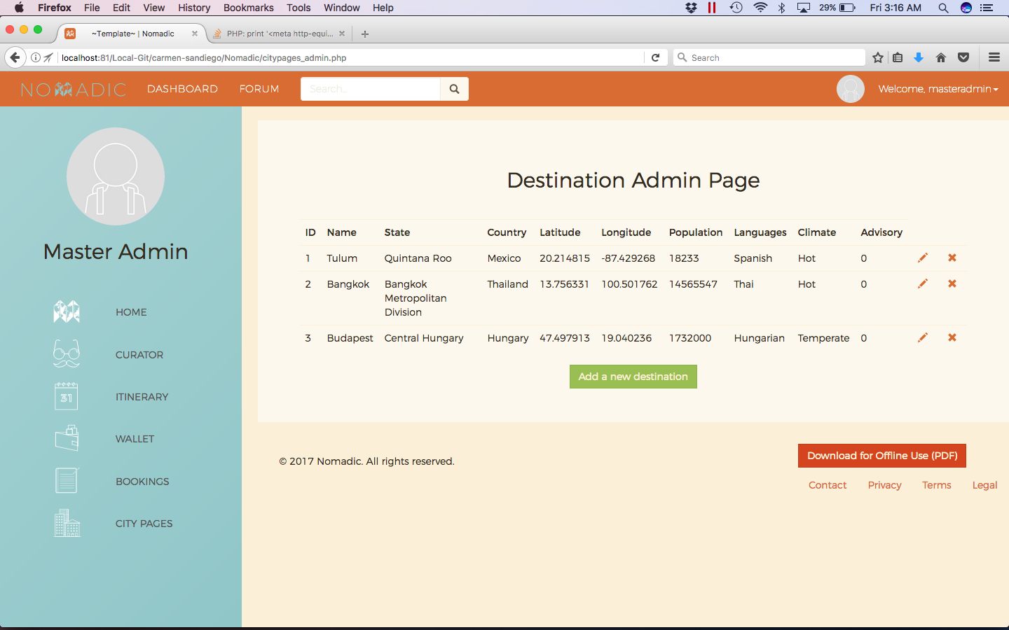

Nomadic City Pages 5/8 (Add Destination)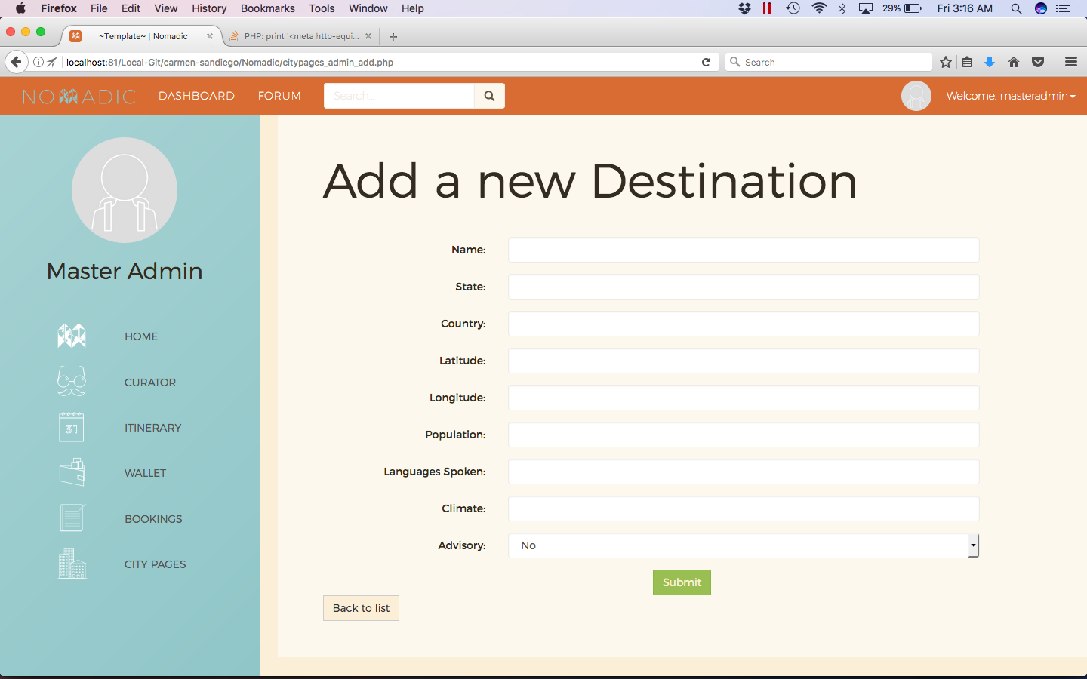

Nomadic City Pages 6/8 (Edit/View Destination)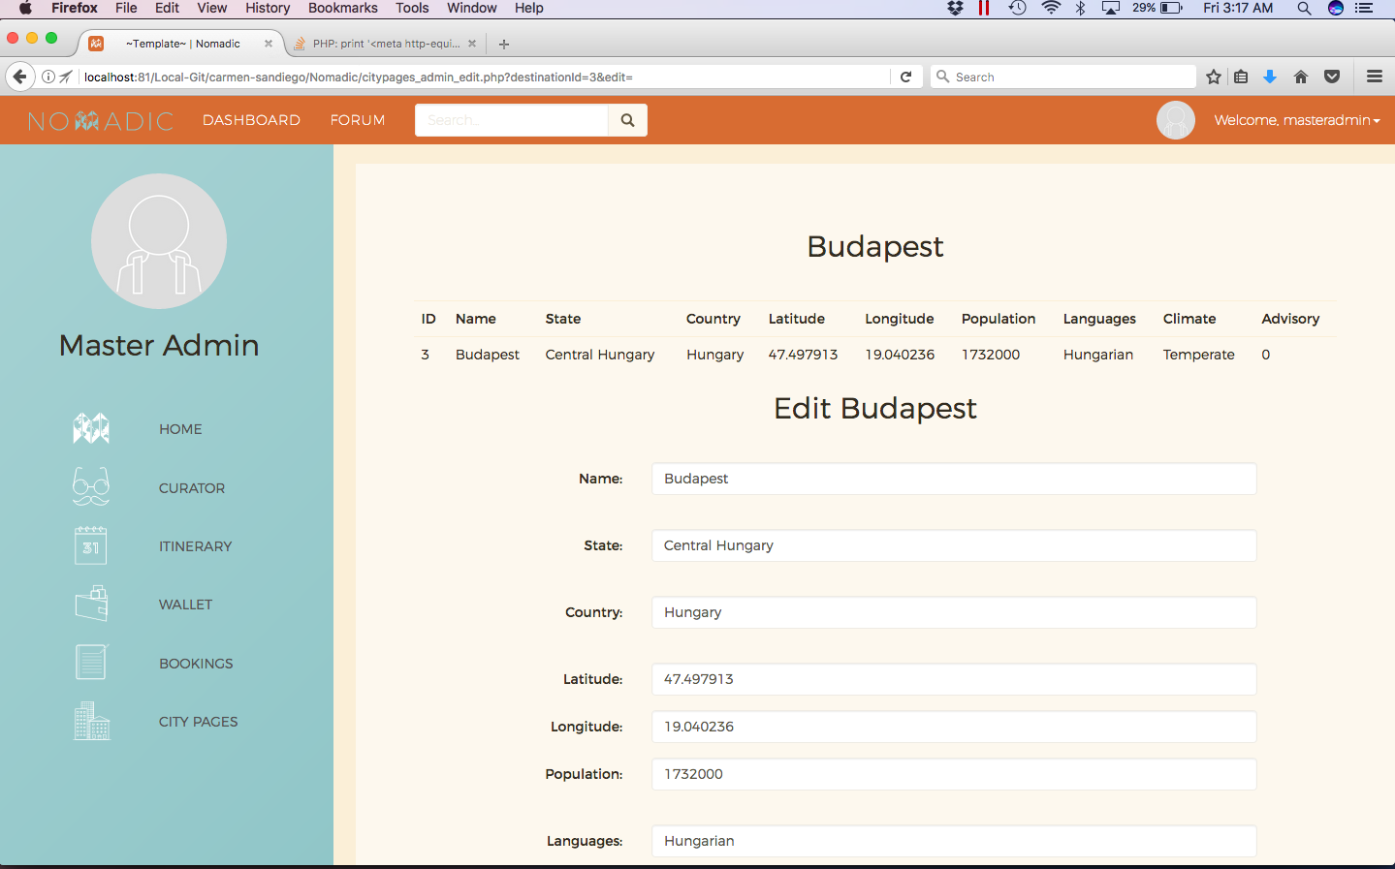

Nomadic City Pages 7/8 (Edit/View Destination Continued)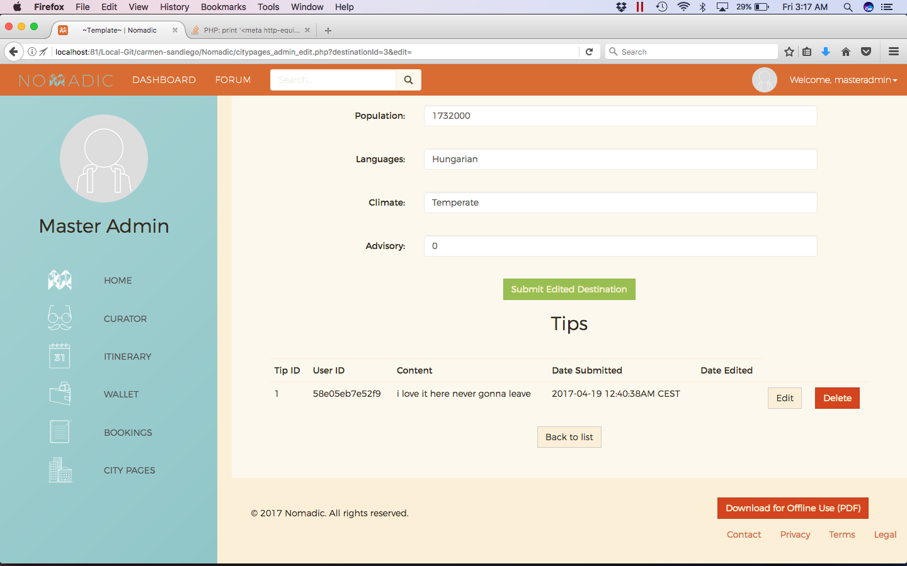

Nomadic City Pages 8/8 (Edit Tip)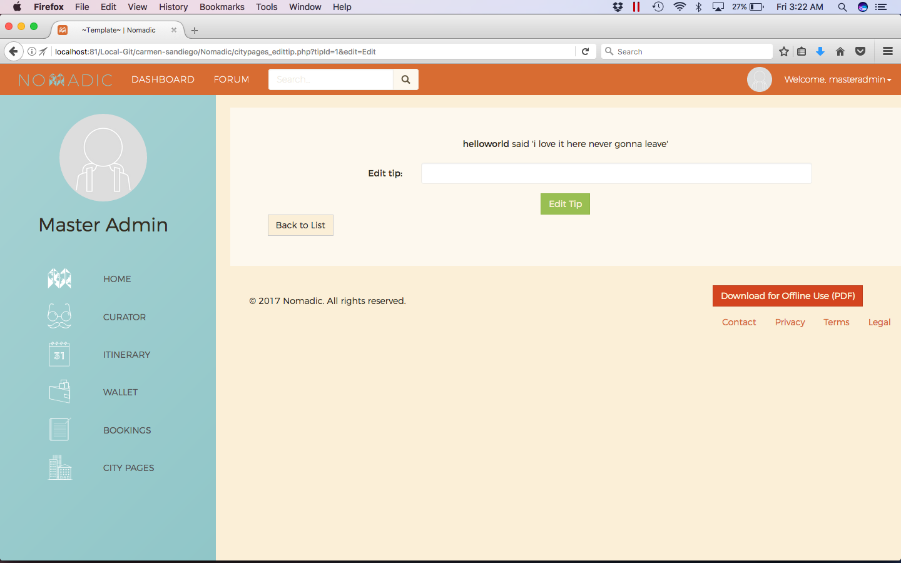

Nomadic User Settings 1/2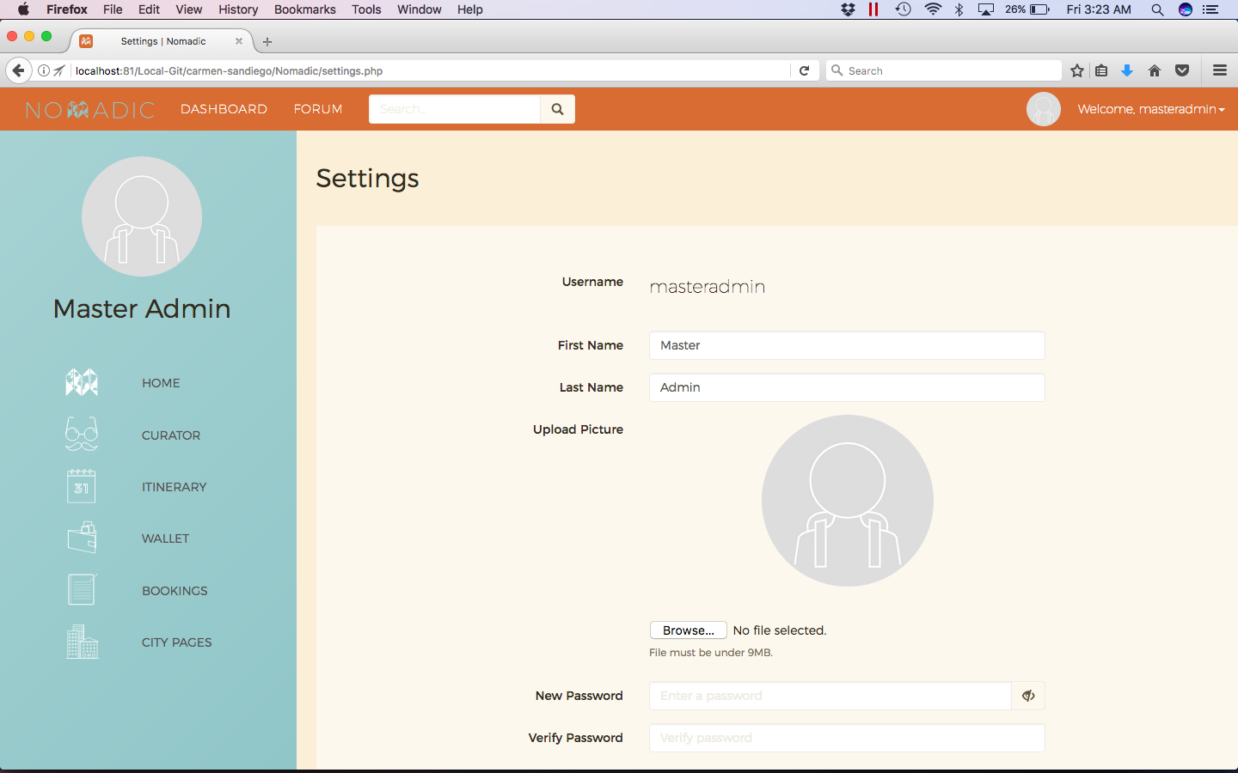

Nomadic User Settings 2/2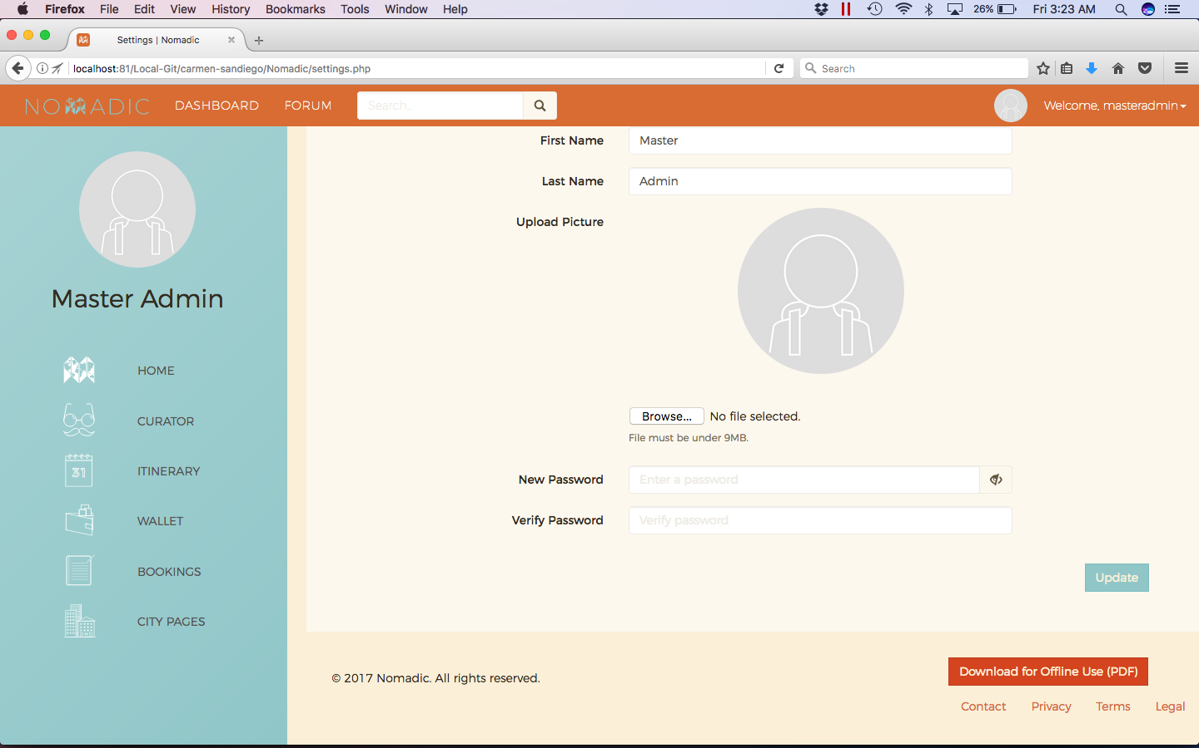

Nomadic User Management 1/2 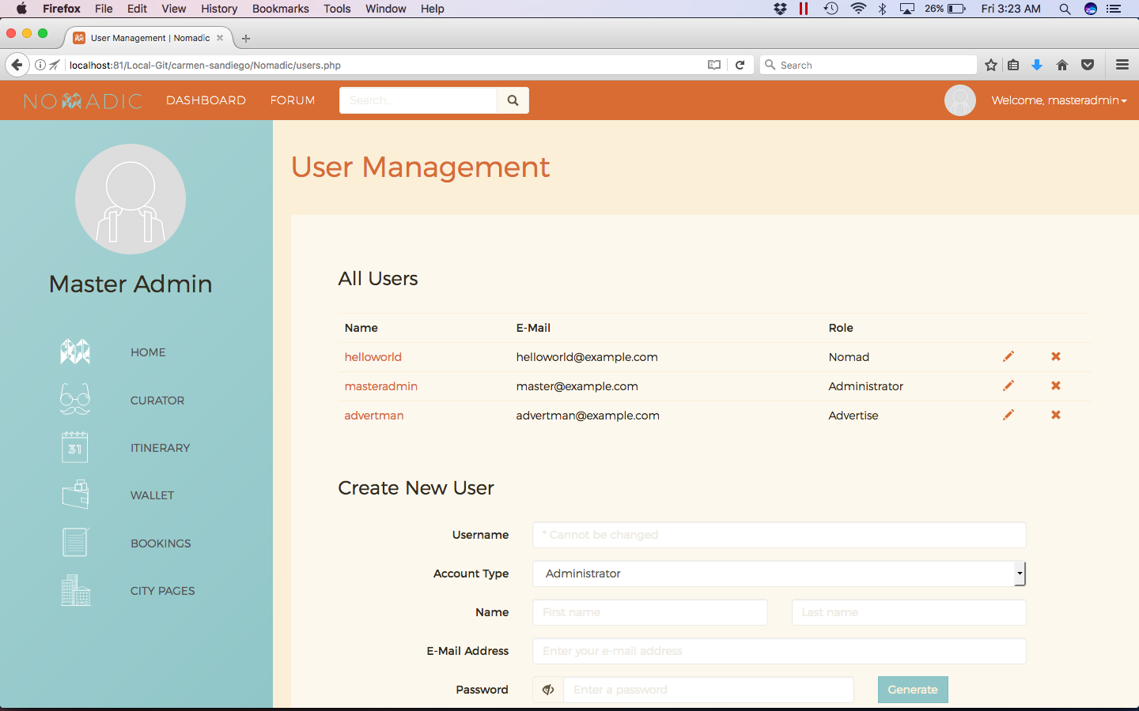

Nomadic User Management 2/2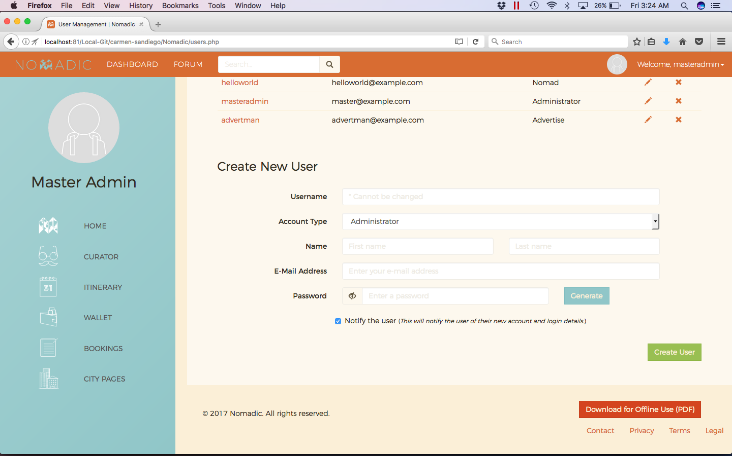

Nomadic Locations 1/2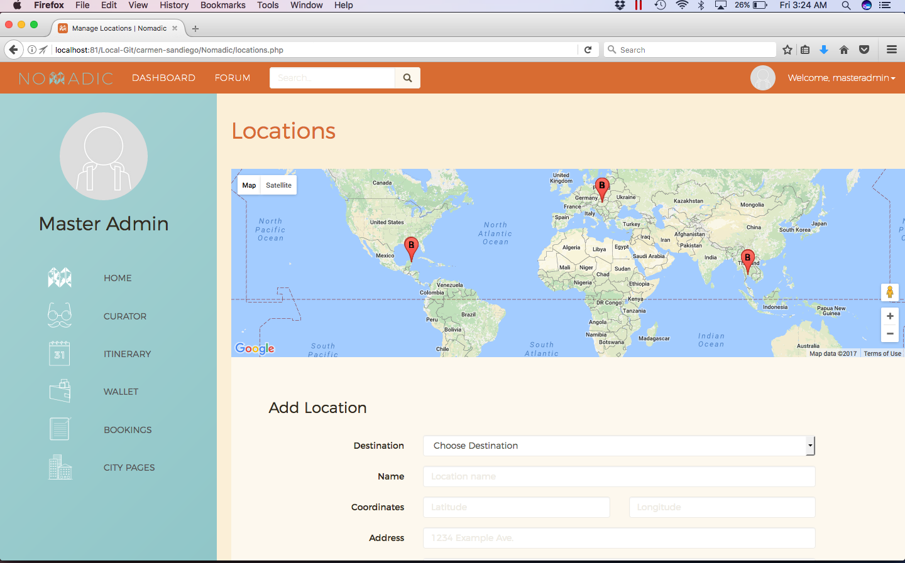

Nomadic Locations 2/2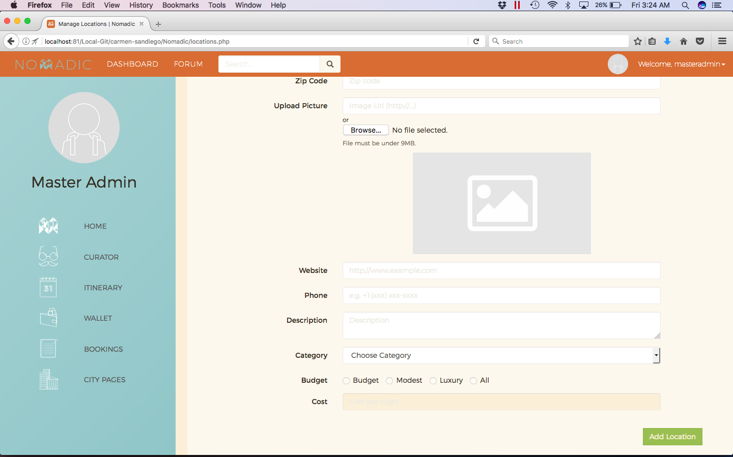

Nomadic Contact Us 1/6 (Submit Form)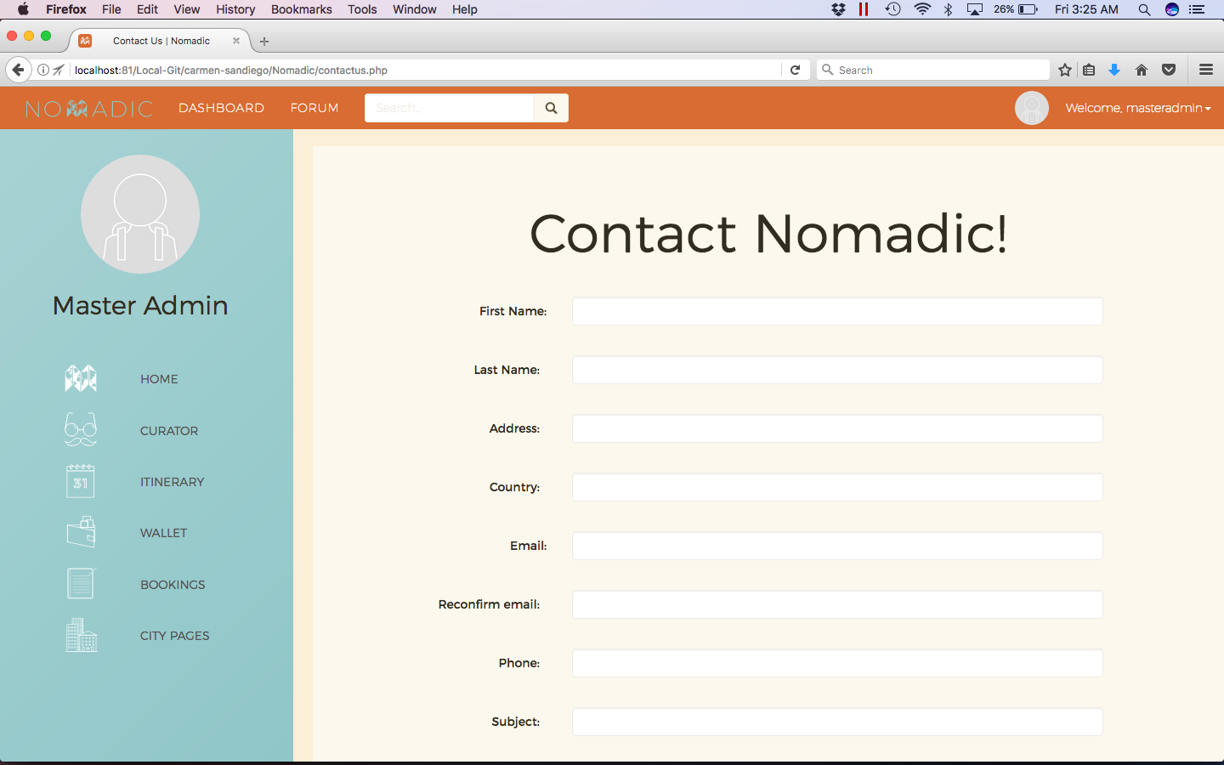

Nomadic Contact Us 2/6 (Submit Form)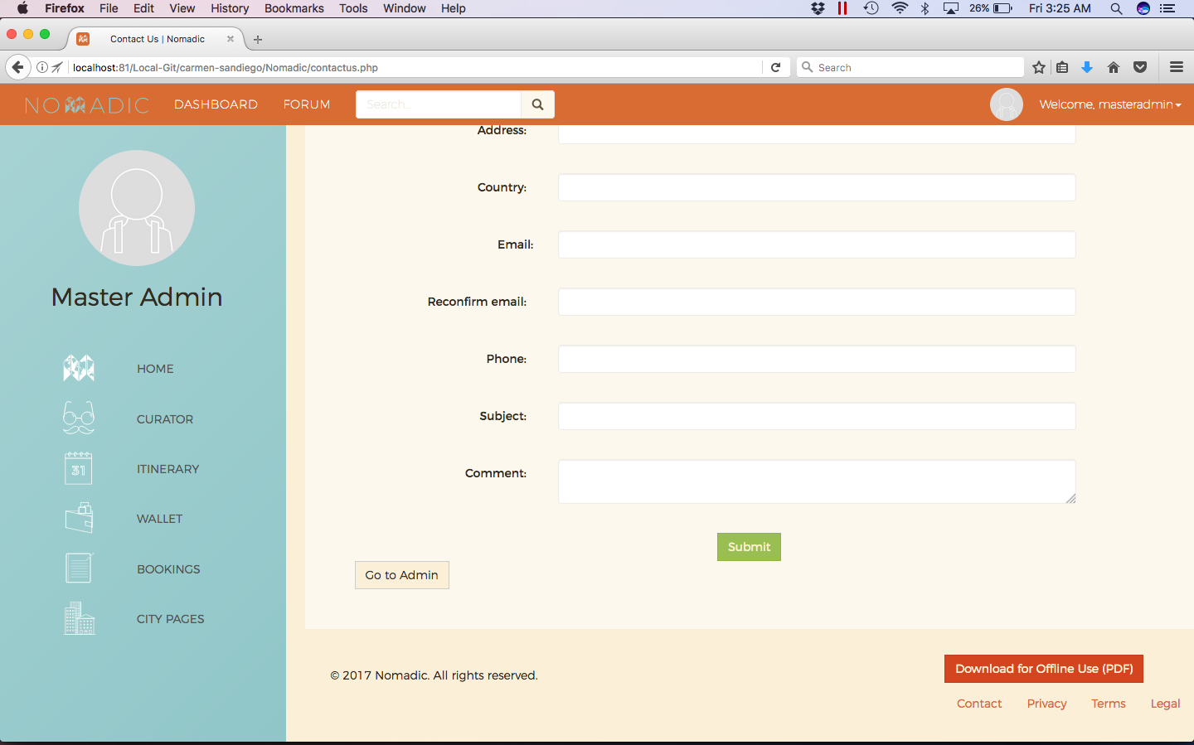

Nomadic Contact Us 3/6 (Administrator View 1/2)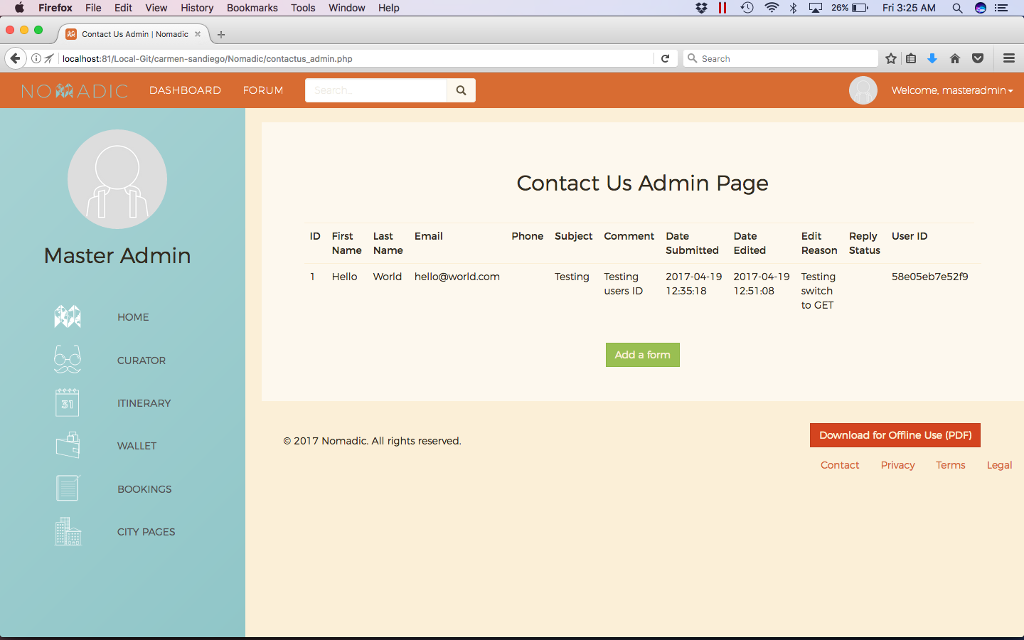

Nomadic Contact Us 4/6 (Administrator View 2/2)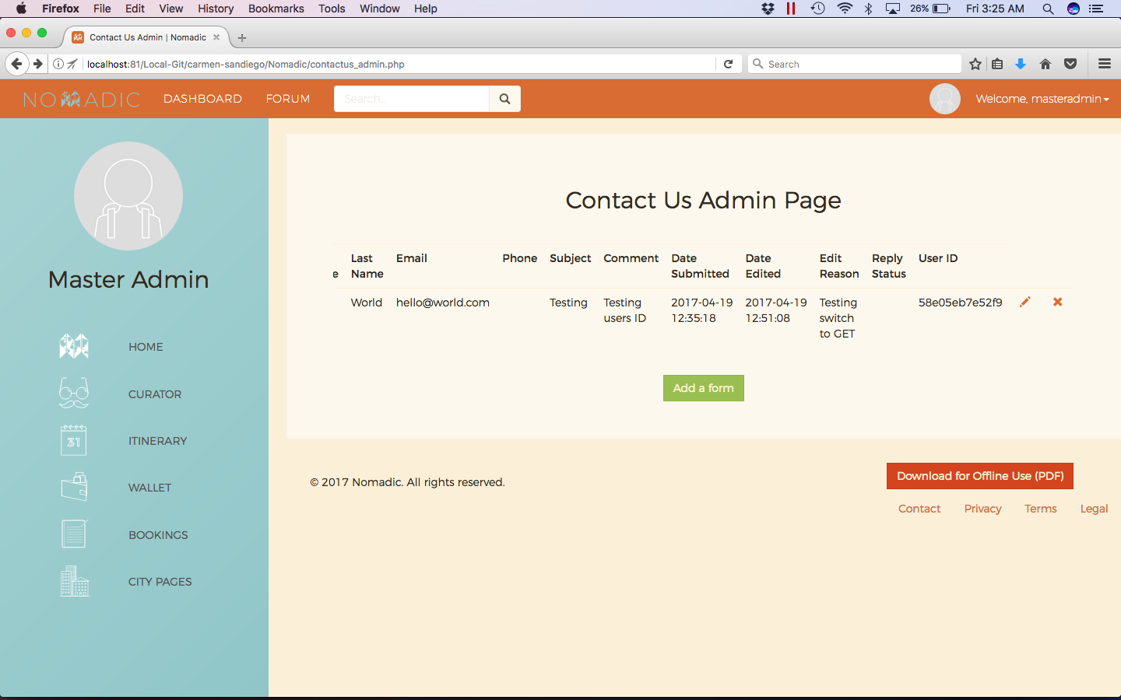

Nomadic Contact Us 5/6 (Administrator Edit/Details of Form 1/2)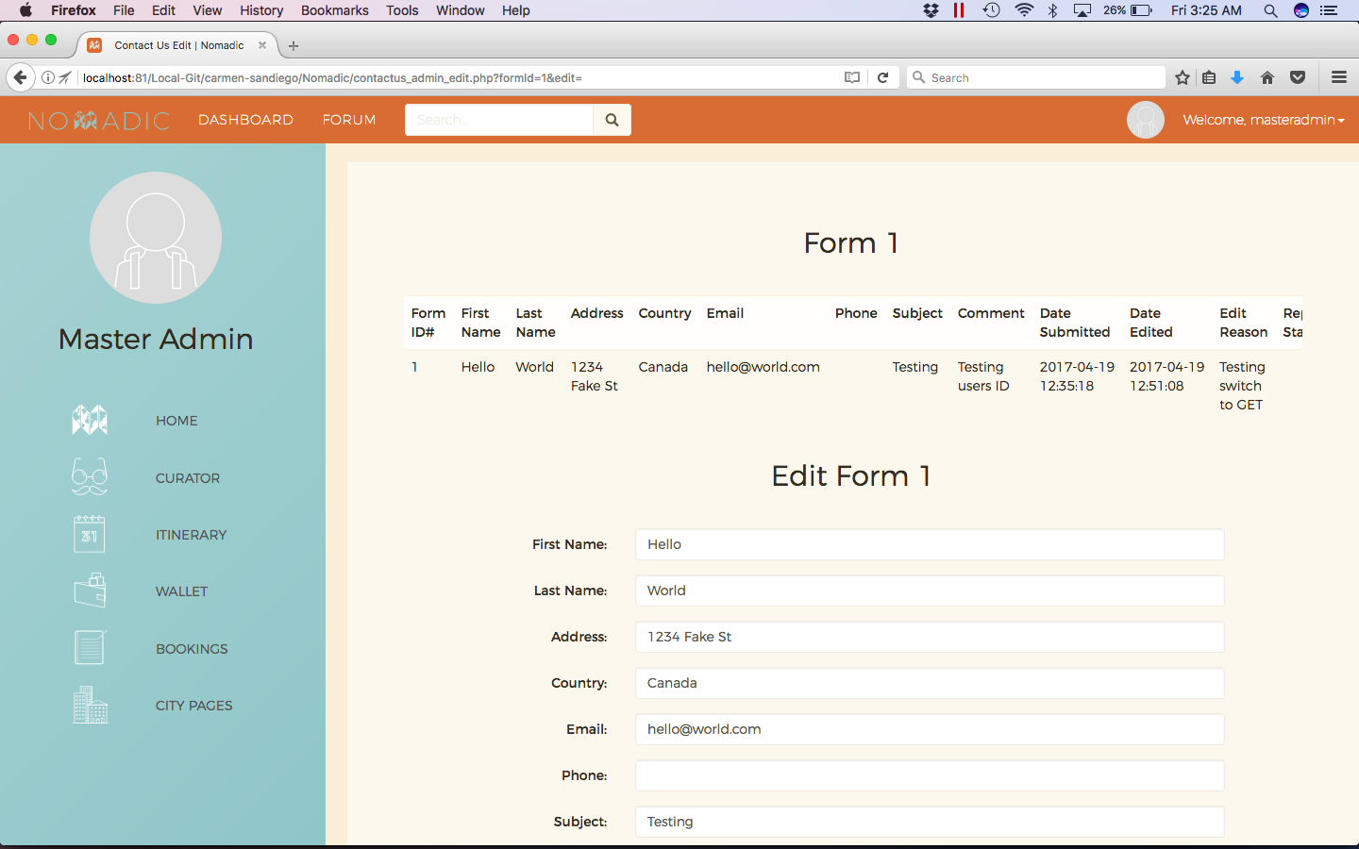

Nomadic Contact Us 6/6 (Administrator Edit/Details of Form 2/2)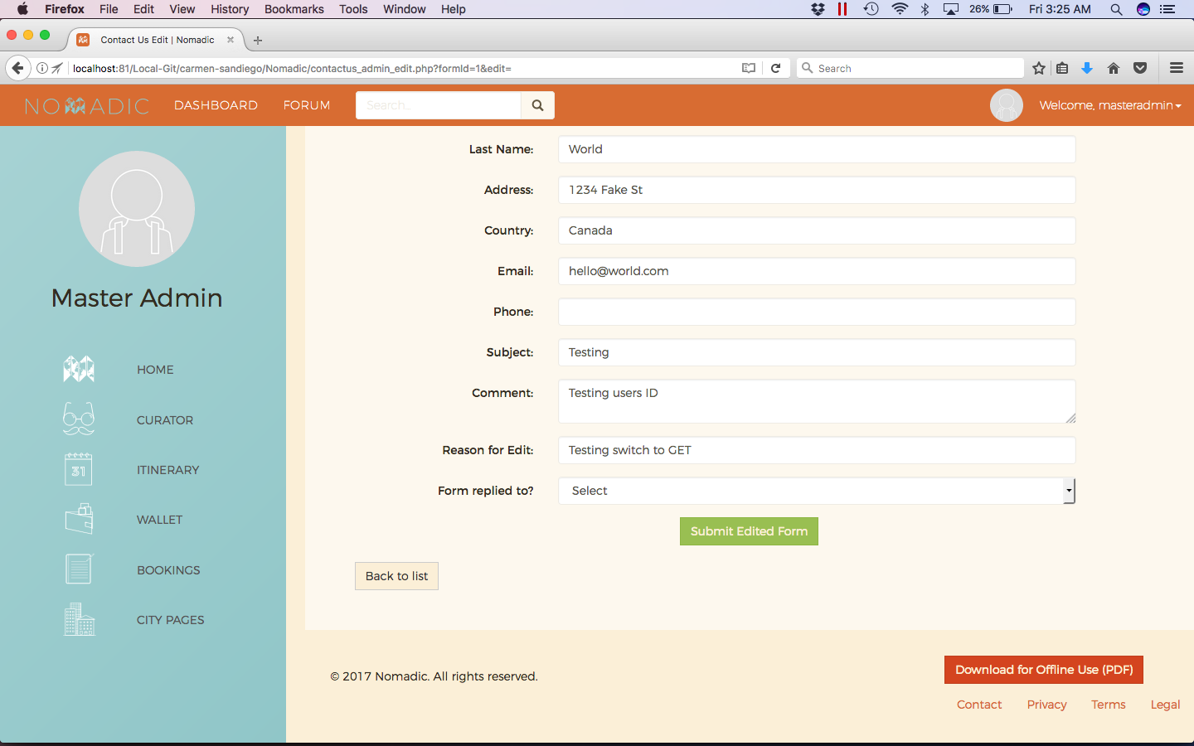

Nomadic Legal 1/4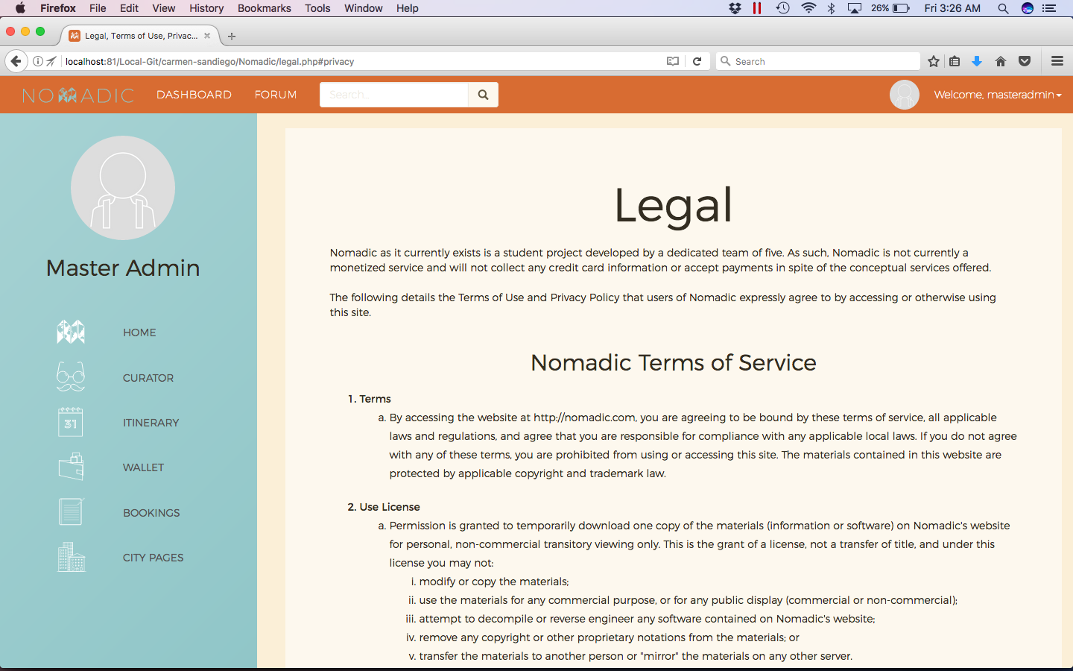

Nomadic Legal 2/4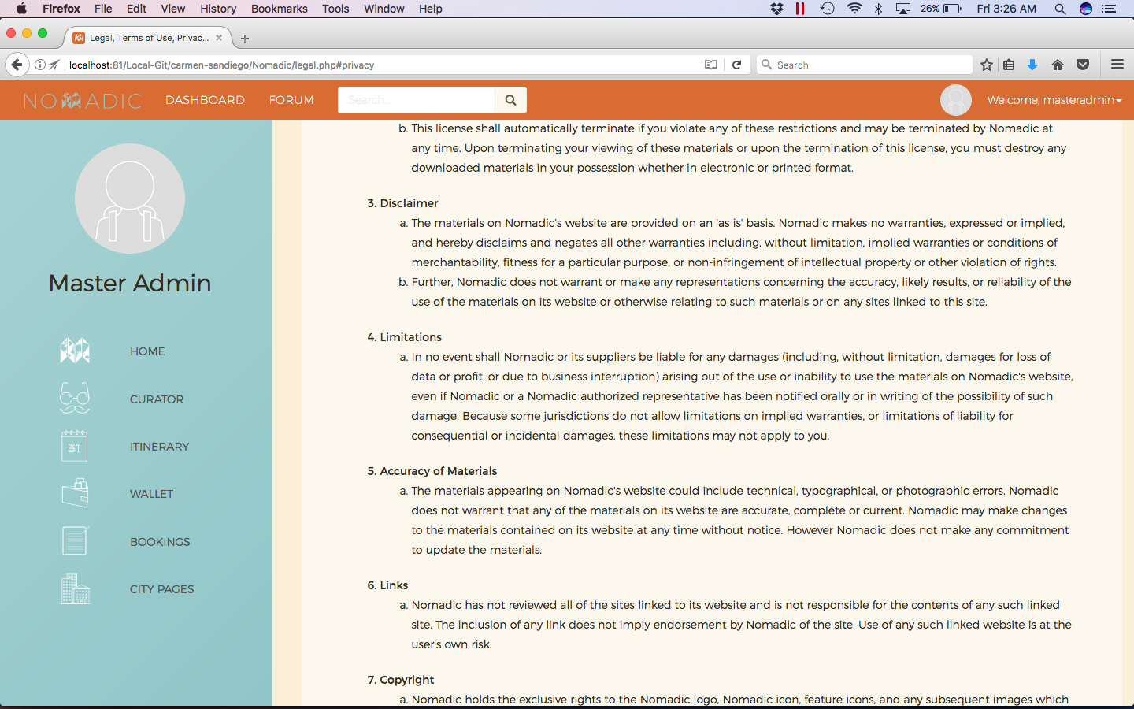

Nomadic Legal 3/4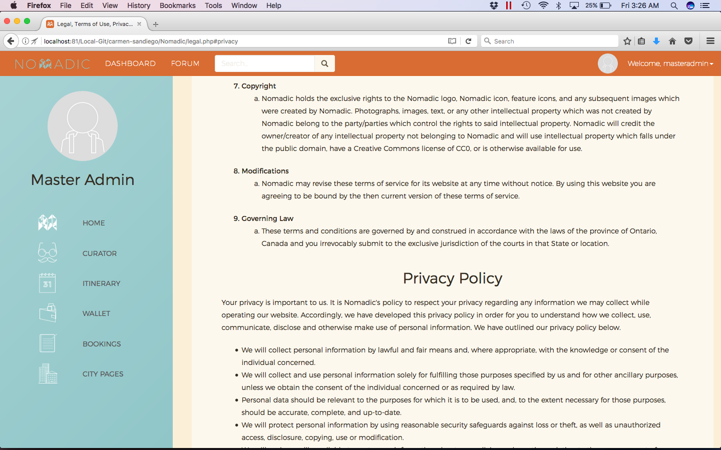

Nomadic Legal 4/4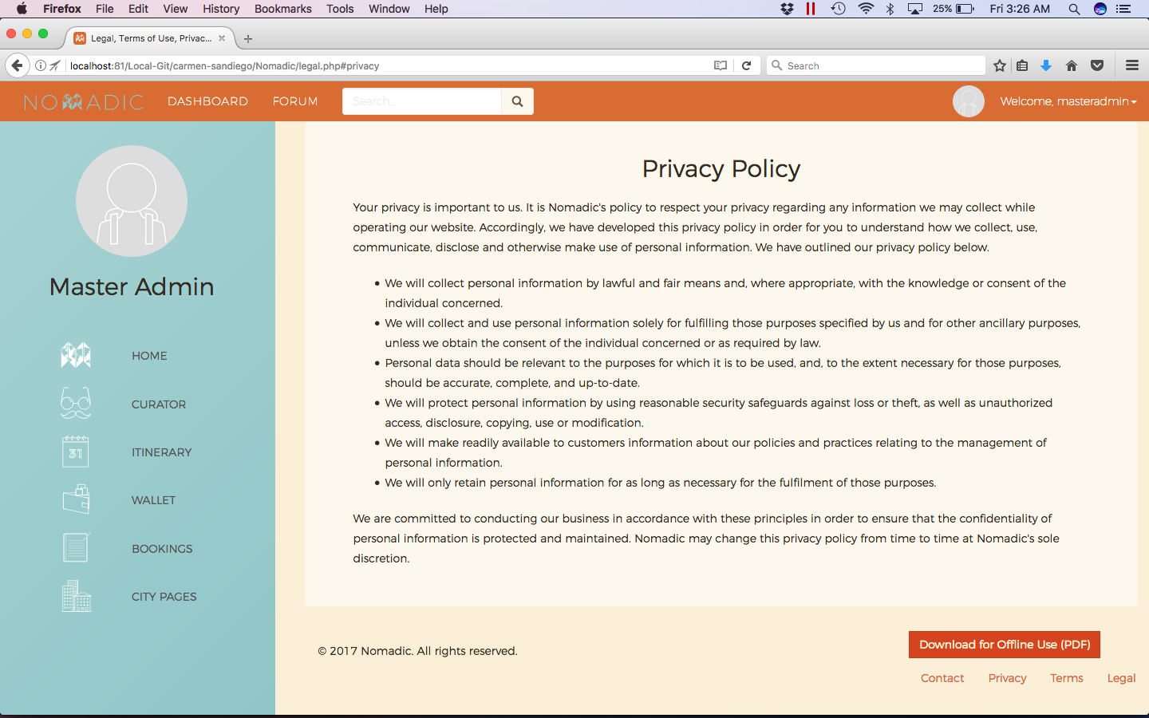

Nomadic Search 1/1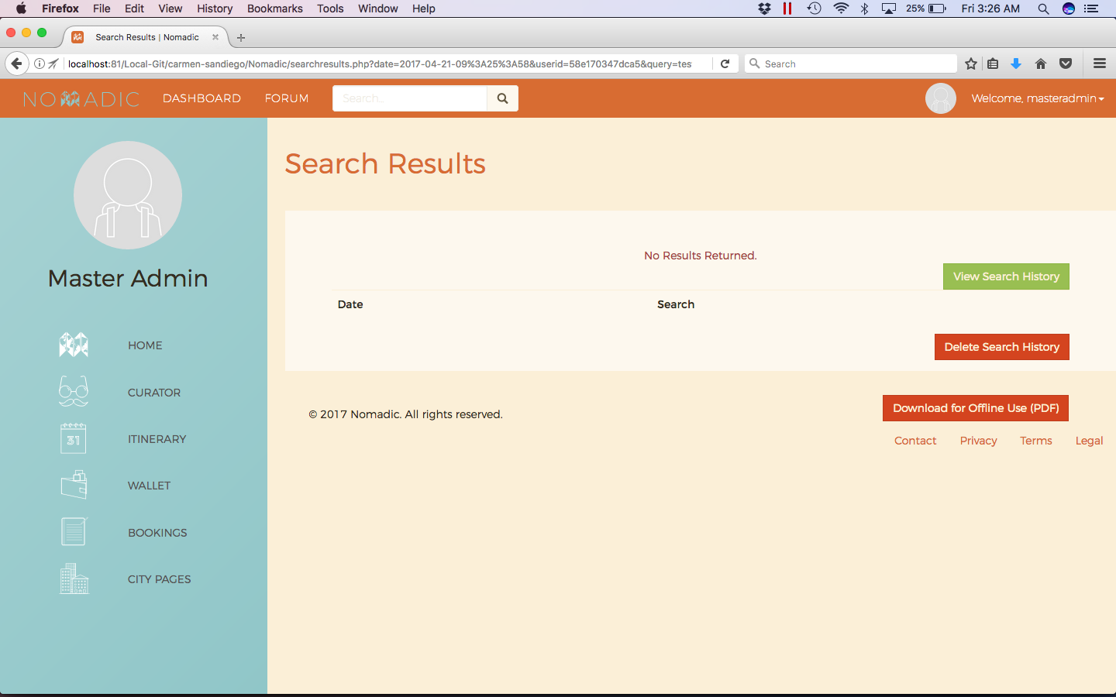

Nomadic Dashboard 1/1